PROJECT REPORT

1 INTRODUCTION

* 1. Overview

In IoT based smart farming, a system is built for monitoring the crop field with help of sensors such as light, humidity, temperature, soil moisture and automating the irrigation system IoT-based smart farming is highly efficient when compared with convention. The farmers can monitor the field conditions from anywhere.

In terms of environmental issues, IoT-based smart farming can provide great benefits including more efficient water usage, or optimization of inputs and treatments. To boost the productivity, decrease the barrier in agriculture field there is need to use innovative technology which we get in IoT

* 1. Purpose

The purpose aims at making agriculture smart using automation and IoT technologies. The highlighting features of this include smart irrigation with smart control based on real time field data. Secondly temperature maintenance , humidity maintenance and object temperature such as soil moisture is taken into consideration.

2 LITERATURE SURVEY

2.1 Existing problems

Agriculturists used to figure the ripeness of soil and influenced presumptions to develop which to kind of product. They didn't think about the dampness, level of water and especially climate condition which horrible an agriculturist more. They utilize few pesticides without having correct knowledge about it which lead to lot of loss in cropping and genuine impact to the yield . This leads to the more problems for the farmers and great loss. Main farmers are facing more problem on irrigating the crops properly according to the requirements.

The farmer may over irrigate the crops and the cropping leads to loss and he may. Though underground water is mainly used for irrigation, surface water is also used by some farmers. Demand for water is increasing. Also due to insufficient rain, plants do not get enough water for their growth and ultimately production of crops is reduced.

There is no correct knowledge about the environmental conditions for the farmers for properly irrigating the crops such as temperature, humidity and soil moisture for proper irrigation and leads to damaging of crops due to over irrigating or less irrigating the crops.

This are some of the main existing problems faced in the field of agriculture by the farmers.

2.2 Proposed solution

The main problem faced by the farmers is on irrigating the crops properly hence main moto is to solve the problem of water irrigation in many areas and fields where the farmer can be able to irrigate at one place and receive the data regarding weather forecasting. The farmer is made aware to start his motor for irrigating the crops based on the notification and can be operated where ever the farmer is connected to internet and get the proper weather forecasting details.

Proper knowledge on using the application and the smart phone through the project in more efficient manner is done. The model is developed in such a way that it can provide the average result for irrigating of the plants and crops grown instead of real time data for a specific area of land.

Here the web app is created using Node red and user interface is created through which the temperature. The IoT simulator is connected to Watson IoT platform and temperature, humidity and object temperature such as soil moisture is controlled and node red is configured to get the data from IBM IOT platform. Then nodes are modified to display the weather parameters which we have received from IOT platform and created an user interface and creating buttons to receive the Motor on and Motor off commands to IoT platform and python code is coded to retrieve the commands from the IOT platform.

1. THEORITICAL ANALYSIS

* 1. Block Diagram

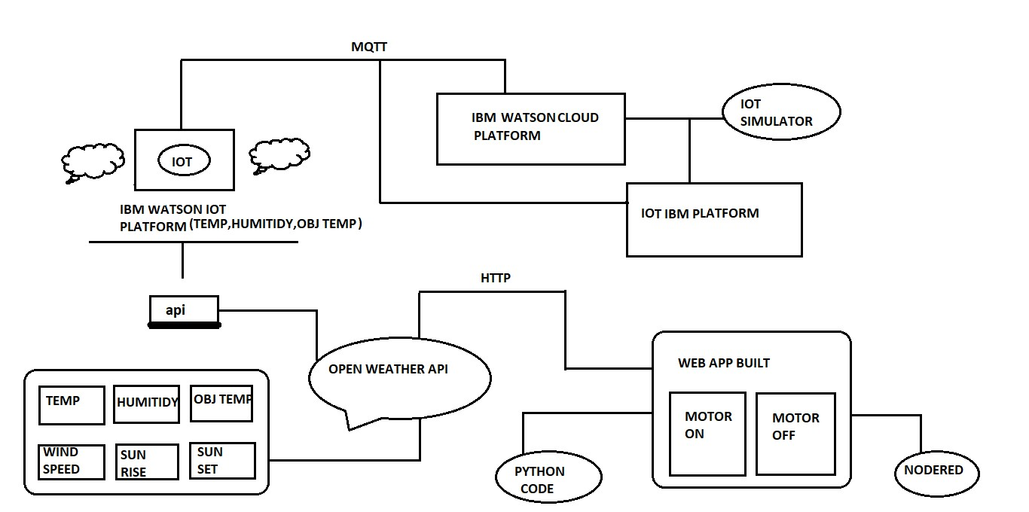

3.2 HARDWARE / SOFTWARE DESIGNING

Hardware Designing

IoT Hardware designing includes Watson IoT Simulator. IBM Watson IoT platform is managed, cloud-hosted service designed to make it simple to derive value from our IoT devices. Watson IoT has blockchain services and analytic service which enables organizations to capture and discover the data for our devices, equipment, and machines and were knowledgeable and useful in decision making. Hardware designing valuable are identified and device behavior and operations such as stimulations are done for the environmental conditions such as temperature, humidity and object temperature such as soil moisture and events made to run and viewed through the graphical representations

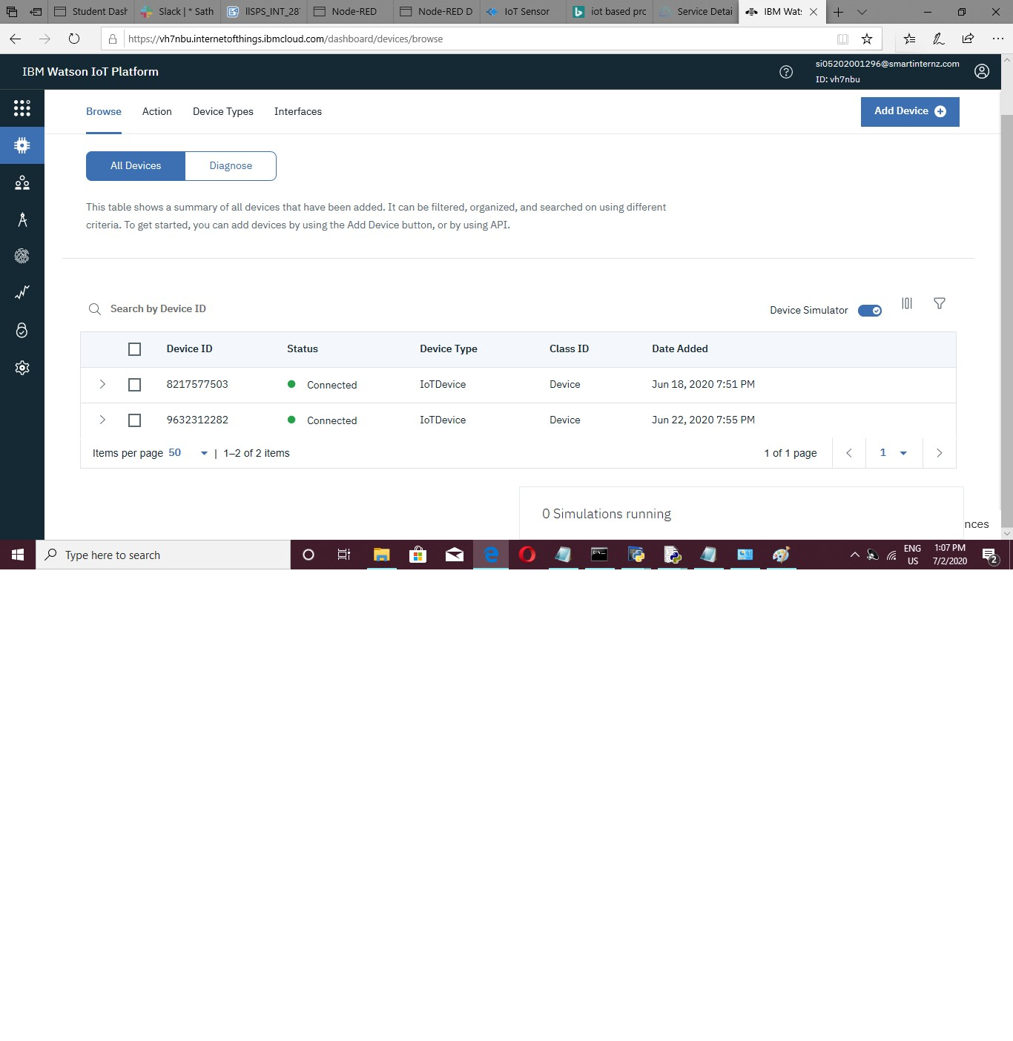

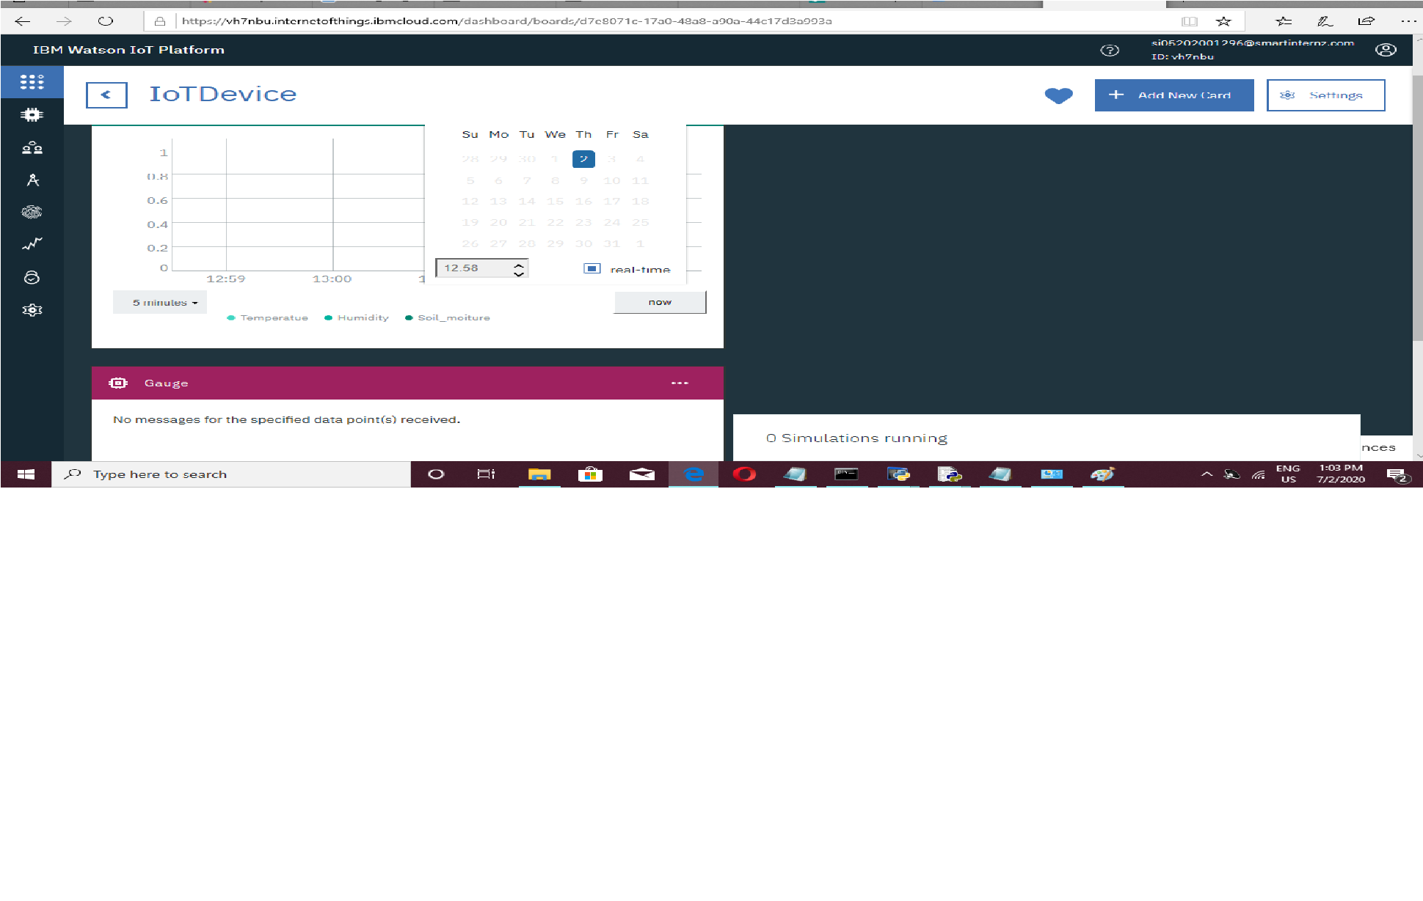

Software Designing

Software designing includes IBM Watson cloud platform and IoT IBM platform which is connected to web app where the motor is controlled by motor on and motor off and in turn it is connected to open Weather API through HTTP networking protocols. IBM Watson cloud includes exploring the IBM cloud platform by created the account in the IBM cloud platform and node red are installed locally and IBM Watson IoT platform is launched where the device is created ,device credentials are noted and stimulated and Idle python ide is installed for coding and receiving the commands such as motor on and motor off ad we connect the

IoT stimulator to Watson IoT platform in the further process we install the required nodes in the node red such as IBM IoT input output node, required function nodes and the gauge nodes , required buttons and http nodes and inject and debug nodes and connecting the our IBM IoT device to stimulate the data according to our requirement . In open weather API the account is created and the open weather platform is configured and API is created and our city as to choose and API followed by the city which we recommended are considered and Http link is created accordingly and with this http link our node red is configured to get weather forecasting data which includes the data on temperature,humitidy,wind speed,sunrise,sunset and time zone etc. These data are parsed with the function nodes.

Then the nodes are configured to display the weather conditions such as temperature,humitidy and object temperature which we have got from the simulator and open weather API in User Interface and the buttons such as motor on and motor off are created and the nodes are configured for sending the commands to IoT platform.

In the Idle python in a new file the python code to subscribe to IBM IoT platform is written and according to our device credentials and pip ibmiotf library is installed in command prompt to run the python program and the device is connected successfully and the commands which are given in the buttons such as motor on and motor off are received here.

4 EXPERIMENTAL INVESTIGATIONS

Experimental investigations are also done while building a smart agriculture system based on IoT. temperature brought on by climate change and including increased drought and flooding, and many more intense and to develop resilience to these threats are necessary for climate-smart management of soil and water. Ecological experiments provide unique testbeds for studying many questions. experimental investigations were main done through the different irrigation systems, investigating soil management and irrigation practices which are important focus for developing the climate smart strategies.

On the environmental investigations the main problem is based on the climatic condition and irrigation facilities is considered and the solutions are given to the problems for the farmers.

In which the farmer can be able to access their fields by irrigating at one place and even collects the data regarding weather forecasting. The farmers are seen through that they are facing the problem in irrigating the crops properly hence main solution is given to that by smart agriculture project bas IoT.

This slows the problem by irrigated the crops properly whenever the crops are needed the water facility and increasing their overall growth in crops production by building the motor off and motor on commands through the user interface access

5 FLOW CHARTS

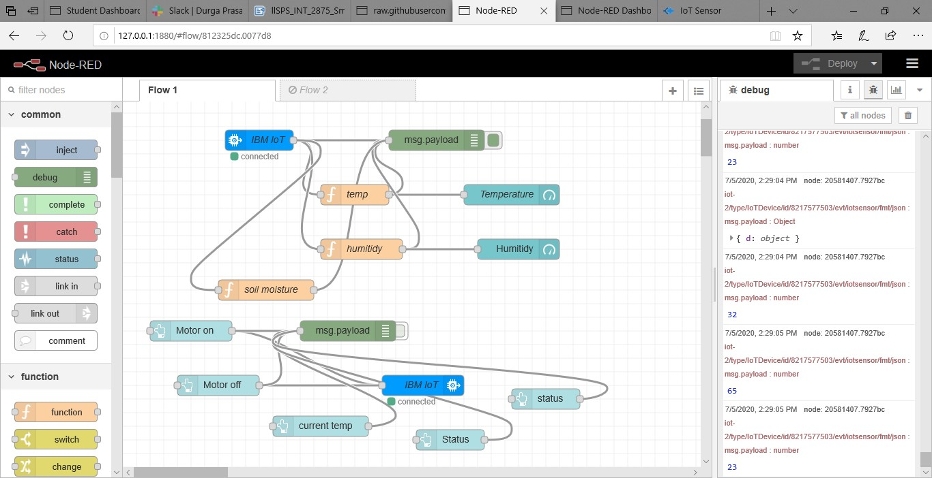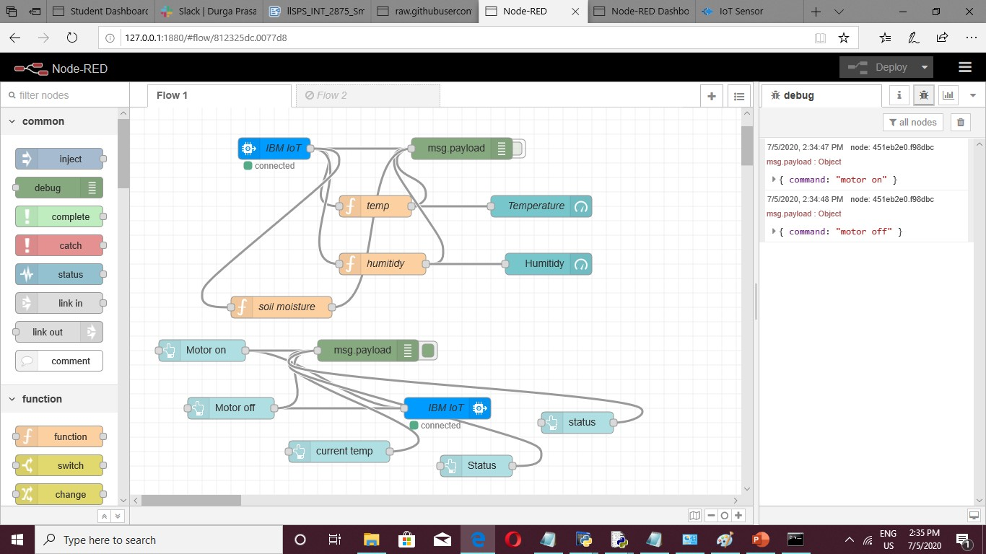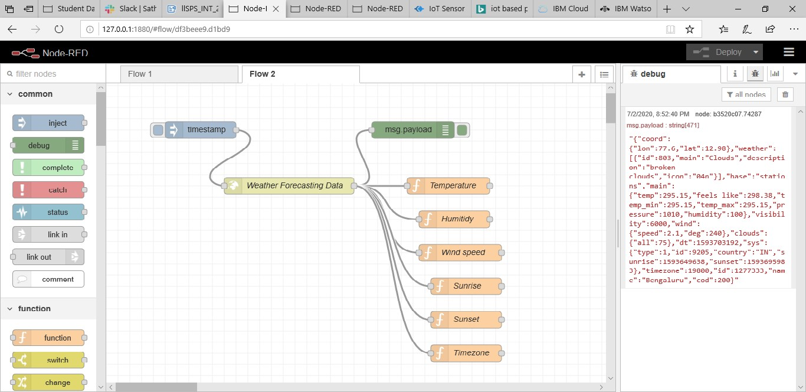

Based on the Project created the first one is the flow chart based on the IBM IoT input and output nodes where the function nodes on the temperature and humidity is coded and connected to the gauge nodes where the temperature and humidity are viewed through the graphical method in the user interface and it controlled with IBM IOT Watson sensor with the help of device credentials and buttons are created and consist of motor on and motor off commands and connected to the IBM IOT output node and the debug node where the commands which are given in the UI are received in the node red. the second flow the http link created in the open weather is added in the http node and inject node and debug node is connected and environmental conditions are parsed to the function nodes to display the output in the node red which is seen in flow created nodes to display the output in the node red which is seen in flow.

6 RESULT

The result obtained is a smart agriculture which is farmer friendly and IoT based Smart Farming improves the entire Agriculture system by monitoring the field in real-time. with the help of sensors and interconnectivity, the internet of things in agriculture has not only saved the time of farmers but has also reduced the extravagant use of resources such as water. At the result we obtain the user interface where we can give the commands such as motor on and motor off, the device is configured and the data is received from the web application motors are controlled and the commands are retrieved in python code.

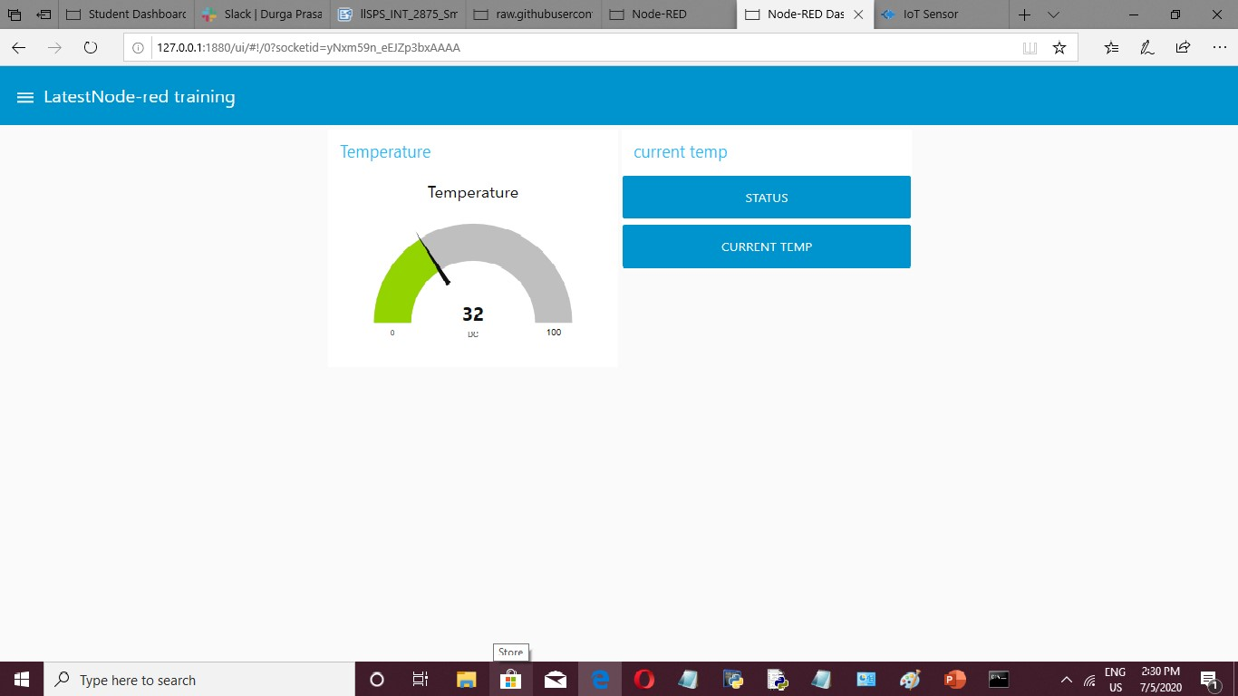

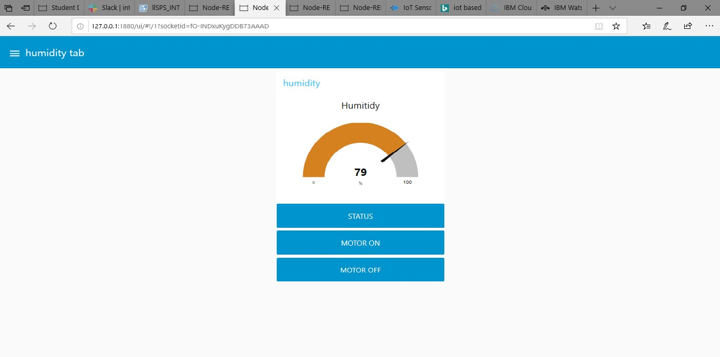

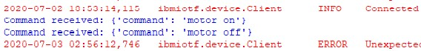

7 ADVANTAGES

Some of the advantages are

I) Data collection, all data can be collected with help of installed sensors. ii) Reduction of risks. iii) Business goes automated. iv) Real-Time Data and production insight.

Lowered operation costs.

v) Water Conservation mainly irrigation is taken to be productive manner. vi) Accurate form and field evaluation. vii) Improved livestock farming. viii) Remote monitoring is also taken care.

DISADVANTAGES

Some of the disadvantages are

1. Study of IoT, understanding IoT architecture, applications, issues and challenges are quite difficult.
2. Money needed for IoT devices are more and are quite expensive.
3. Internet facility is not available all the time, it is difficult to operate when there is poor network. iv) Over reliance on technology. v) Breach of privacy.

vi) Loss of jobs and unemployment increases.

8 APPLICATIONS

The main applications are

I) climate conditions: were climate plays very critical role for farming, IoT solution enables us to know the real time weather conditions. Sensors they collect the data from the environment which is used irrigate the crops at the right time according to the particular climatic conditions. Sensors detect real time data on weather, humidity, temperature and object temperature. ii) Smart Greenhouse: IoT has enabled weather stations to automatically adjust the climate conditions, it is cost effective and increasing accuracy at the same time. Irrigation is improved with the help of the sensors where water consumption is monitored by motor on and motor off commands.

iii) Data Analytics: Cloud based data storage and an end to end IoT platform plays an important role such that better activities can be performed. In the IoT world, sensors are the primary soured of collecting data on a large scale. The data is analyzed and transformed to meaningful information using analytics tools.

v) Agricultural Drones: Technological advancements has almost revolutionized the agricultural operations and the introduction of agricultural drones is the trending disruption. vi)Precision farming and advanced irrigation facility: the farming practice more precise and controlled by realizing smart farming applications such as livestock monitoring and irrigation facility is increased dankly for profitable production.

* 1. CONCLUSION

IoT enabled Smart Agriculture has helped to implement modern technological solutions to time testes knowledge. This has helped bridge the gap between production and quality and quantity yield data ingested by obtaining and importing information from the multiple sensors for real time usage and with seamless end to end intelligent operations and improved business process execution and production gets processed faster and reaches supermarkets in fastest time possibility for severing the consumers at faster rate. The points of interest like motor on motor off work sparing are started utilizing sensors that work consequently as they are modified. This idea of modernization of farming is straightforward, reasonable and operable.

10 FUTURE SCOPE

IoT sensors capable of providing farmers with information about crop yields, rainfall, mainly about irrigation practices for production of crops in the productive manner in the future and soil nutrition are invaluable to production and offer precise data which can be used to improve farming techniques over time offering high precision crop control ,useful data collection, and automated farming techniques ,there are clearly many advantages for the future farming. It also describes about farming in the future climate change, limited arable land, and costs/availability of water resources. IoT sensors with updated format can still help productively for the farmers for irrigating the crops in more efficient manner. It could also potentially allow farmers to induce drought or other abnormal conditions producing desirable traits in specific crops that typically does not occur in nature. This allows users very precise control to document and share or recreate a specific environment for growing and removes the element of poor weather conditions and human error. With a future of efficient, data-driven, highly precise farming methods, it is definitely safe to call this type of farming smart and we can expect IoT will forever change the way we grow food and increasing the production in profitable manner.

11 BIBILOGRAPHY

1. M.K Gayatri, J Jayalakshmi, Dr.G.S. Anandhamala, Giving Smart

Agriculture Solutions to Farmers for Better Yielding Using IoT, IEEE International Conference on Technological Innovations in ICT for Agriculture and Rural.

1. https://www.biz4intellia.com
2. https://www.ijrte.org
3. https://drive.google.com/file/d/18-e2ZNI2bvCut_Tc9M-weRY f8wdTeLY/view?usp=sharing
4. https://drive.google.com/file/d/1xwyGViyV25IJIaT_td5jNzW CcGD1mIsm/view?usp=sharing
5. https://drive.google.com/file/d/1SBiOQrnKQqmiMXwnCt5jky M1UI/view?usp=sharing
6. https://drive.google.com/file/d/1yDcseVVpBDKXoTDMTsGO WIHUfG2POYEE/view?usp=sharing

APPENDIX

A. Source code https://github.com/rachuriharish23/ibmsubscribe